All tutorials related to git

<https://www.freecodecamp.org/news/tag/git/>

merge conflict

<https://www.freecodecamp.org/news/resolving-git-conflicts-62bd357ed5f/>

Git stash

<https://www.theserverside.com/definition/git-stash>

GIT FETCH AND PULL

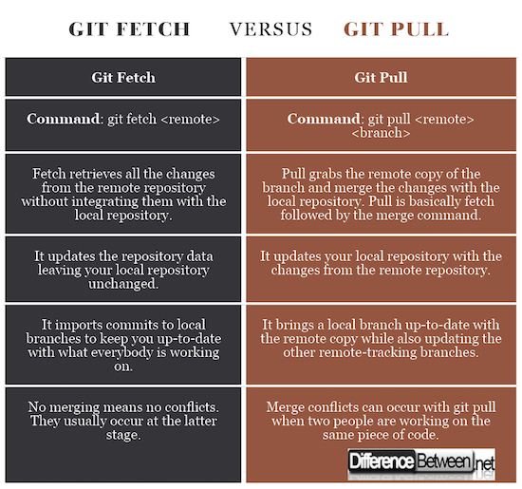

GIT REBASE and GIT MERGE

<https://www.perforce.com/blog/vcs/git-rebase-vs-git-merge-which-better>